Merge Sort - Recursive

Merge sort is an O(*n log n*) **comparison-based sorting algorithm**.

Most implementations produce a **stable sort**, meaning that the implementation preserves the input order of equal elements in the sorted output. It is a **divide and conquer algorithm**. Merge sort was invented by John von Neumann in 1945.

Merge sort incorporates two main ideas to improve its runtime:

1. A small list will take fewer steps to sort than a large list.
2. Fewer steps are required to construct a sorted list from two sorted lists than two unsorted lists. For example, we only have to traverse each list once if they're already sorted.

Here is the description from the book "Introduction To ALGORITHMS" by Cormen et al. (2009)  
A merge sort algorithm closely follows the divide-and-conquer paradigm:

1. Divide the n-element sequence to be sorted into two **subsequences**of *n/2* elements each.
2. Sort the two subsequences **recursively** by re-applying merge sort.
3. **Merge** the two sorted subsequences to produce the sorted answer.

The divide-and-conquer paradigm involves three steps at each level of the recursion:

1. **Divide** the problem into a number of subproblems that are smaller instances of the same problem.
2. **Conquer** the subprograms by solving them recursively. If the subproblem sizes are small enough, however, just solve the subproblems in a straightforward manner.
3. **Combine** the solutions to the subproblems into the solution for the original problem.

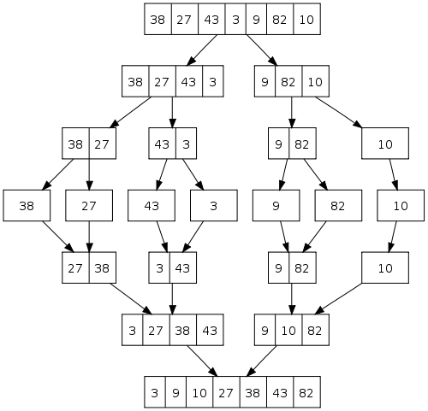

Merge Sort - code A

C++ code

#include <iostream>

#include <vector>

using namespace std;

void print(vector<int> v)

{

for(int i = 0; i < v.size(); i++) cout << v[i] << " ";

cout << endl;

}

vector<int> merge(vector<int> left, vector<int> right)

{

vector<int> result;

while ((int)left.size() > 0 || (int)right.size() > 0) {

if ((int)left.size() > 0 && (int)right.size() > 0) {

if ((int)left.front() <= (int)right.front()) {

result.push_back((int)left.front());

left.erase(left.begin());

}

else {

result.push_back((int)right.front());

right.erase(right.begin());

}

} else if ((int)left.size() > 0) {

for (int i = 0; i < (int)left.size(); i++)

result.push_back(left[i]);

break;

} else if ((int)right.size() > 0) {

for (int i = 0; i < (int)right.size(); i++)

result.push_back(right[i]);

break;

}

}

return result;

}

vector<int> mergeSort(vector<int> m)

{

if (m.size() <= 1)

return m;

vector<int> left, right, result;

int middle = ((int)m.size()+ 1) / 2;

for (int i = 0; i < middle; i++) {

left.push_back(m[i]);

}

for (int i = middle; i < (int)m.size(); i++) {

right.push_back(m[i]);

}

left = mergeSort(left);

right = mergeSort(right);

result = merge(left, right);

return result;

}

int main()

{

vector<int> v;

v.push_back(38);

v.push_back(27);

v.push_back(43);

v.push_back(3);

v.push_back(9);

v.push_back(82);

v.push_back(10);

print(v);

cout << "------------------" << endl;

v = mergeSort(v);

print(v);

}

Output from the run:

38 27 43 3 9 82 10

------------------

3 9 10 27 38 43 82

Merge Sort - code B

Or using arrays:

#include <iostream>

using namespace std;

void print(int a[], int sz)

{

for (int i = 0; i < sz; i++) cout << a[i] << " ";

cout << endl;

}

void merge(int a[], const int low, const int mid, const int high)

{

int *temp = new int[high-low+1];

int left = low;

int right = mid+1;

int current = 0;

// Merges the two arrays into temp[]

while(left <= mid && right <= high) {

if(a[left] <= a[right]) {

temp[current] = a[left];

left++;

}

else { // if right element is smaller that the left

temp[current] = a[right];

right++;

}

current++;

}

// Completes the array

// Extreme example a = 1, 2, 3 || 4, 5, 6

// The temp array has already been filled with 1, 2, 3,

// So, the right side of array a will be used to fill temp.

if(left > mid) {

for(int i=right; i <= high;i++) {

temp[current] = a[i];

current++;

}

}

// Extreme example a = 6, 5, 4 || 3, 2, 1

// The temp array has already been filled with 1, 2, 3

// So, the left side of array a will be used to fill temp.

else {

for(int i=left; i <= mid; i++) {

temp[current] = a[i];

current++;

}

}

// into the original array

for(int i=0; i<=high-low;i++) {

a[i+low] = temp[i];

}

delete[] temp;

}

void merge_sort(int a[], const int low, const int high)

{

if(low >= high) return;

int mid = (low+high)/2;

merge_sort(a, low, mid); //left half

merge_sort(a, mid+1, high); //right half

merge(a, low, mid, high); //merge them

}

int main()

{

int a[] = {38, 27, 43, 3, 9, 82, 10};

int arraySize = sizeof(a)/sizeof(int);

print(a, arraySize);

merge_sort(a, 0, (arraySize-1) );

print(a, arraySize);

return 0;

}

Merge Sort - code C

Another slightly different version: Copying only the left side of helper array (**b**) elements into the original array (**a**) in **Merge()**.

#include <iostream>

// a: original, b: helper array

void merge(int a[], int b[], int low, int mid, int high)

{

for(int i = low; i <= high; i++) {

b[i] = a[i];

}

int left = low;

int right = mid+1;

int index = low;

while(left <= mid && right <= high) {

if(b[left] <= b[right])

a[index++] = b[left++];

else

a[index++] = b[right++];

}

// copy remainder of the left side

int remainder = mid - left +1;

for(int i = 0; i < remainder; i++) {

a[index+i] = b[left+i];

}

}

// merge sort starts here

void mergeSort(int a[], int b[], int low, int high)

{

if(low >= high) return;

int mid = (low+high)/2;

mergeSort(a, b, low, mid);

mergeSort(a, b, mid+1, high);

merge(a, b, low, mid, high);

}

// prepare for real mergesort()

void mergeSort(int a[], int len)

{

int *b = new int[len];

mergeSort(a, b, 0, len-1);

delete[] b;

}

int main()

{

int a[] = {9,8,7,6,5,4,3,2,1,0};

int size = sizeof(a)/sizeof(int);

mergeSort(a, size);

return 0;

}

Comparison with other sort algorithms

Although **heapsort** has the same time bounds as **merge sort**, it requires only **O(1)** auxiliary space instead of merge sort's **O(n)**, and is often faster in practical implementations. On typical modern architectures, efficient **quicksort** implementations generally outperform **mergesort** for sorting RAM-based arrays.

On the other hand, **merge** sort is a **stable** sort, **parallelizes better**, and is more efficient at handling slow-to-access **sequential media**. Merge sort is often the best choice for sorting a **linked list**: in this situation it is relatively easy to implement a merge sort in such a way that it requires only **O(1)** extra space, and the slow random-access performance of a linked list makes some other algorithms (such as **quicksort**) perform poorly, and others (such as **heapsort**) completely impossible.

nlog(n)?

How many levels does the recursion tree have as a function of length of an input array, n?   
ans: log2(n)

At each level l = 0, 1, 2, ..., log2(n), there are 2^l subproblems, each of size n/(2^l).   
So, in each level of the recursion tree, the amount of work to be done   
2^l * n/(2^l) = n   
Note that the level, **l**, is not there. The work to be done in each level is actually level-independent. This is because we have smaller size of elements while we have more subproblems as we go deep down the level. They are cancelled out.

(work per level) * (number of levels) = n * log2(n)

In the merge stage, it takes about n.

So, total time would be :  
n*log(n) + n ~ nlog(n)

Inversion counting using merge sort

(4, 3, 1, 2) => 5 inversions which are (4,3) (4,1) (4,2) (3,1) (3,2)

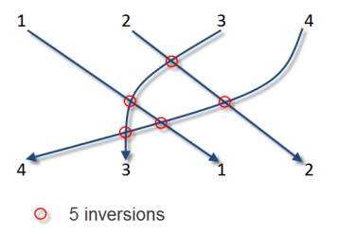

The complexity of using brute force approach is O(n^2), however, if we use sorting, we can reduce it to O(N log N).

By modifying the **merge()**, we can count the number of inversion in the sequence. When we do insert an element from the right side, we can count the number of elements after the index where we insert utilizing the fact that the inversions are precisely the number of elements left in the 1st part of array **b** when we copy the 2nd part of **b** to original array **a**. So, we just add the number to the global variable **inversion**:

int inversion;

// a: original, b: helper array

void merge(int a[], int b[], int low, int mid, int high)

{

for(int i = low; i <= high; i++) {

b[i] = a[i];

}

int left = low;

int right = mid+1;

int index = low;

while(left <= mid && right <= high) {

if(b[left] <= b[right])

a[index++] = b[left++];

else {

inversion += mid - left + 1;

a[index++] = b[right++];

}

}

// copy remainder of the left side

int remainder = mid - left +1;

for(int i = 0; i < remainder; i++) {

a[index+i] = b[left+i];

}

}